Chorus Membership Acceptance Form: 2021-2022

The Bach Society Chorus is an auditioned ensemble of experienced singers committed to artistic excellence in the performance of choral and choral-orchestral masterpieces, notably the works of Johann Sebastian Bach.

Bach Society Chorus Members are expected to:
- Be fully vaccinated against COVID-19 by August 30, 2021 (proof of vaccination required)
- Abide by all guidelines listed in the Rehearsal Safety Protocol document
- Comply with the rehearsal and performance schedule and commit to participation for the full concert season (approximately September 2021 – May 2022)
- Maintain a high level of musical excellence by coming prepared for each rehearsal
- Be good stewards of distributed sheet music and prepared to pay for a replacement if necessary
- Follow performance attire guidelines
- Notify the Music Director of any absences or late arrivals
- Abide by the Anti-Discrimination and Anti-Harassment Policy, included as an addendum to this form
- Read weekly email communications and respond to necessary inquiries

COMMITMENT:
I have read and pledge my commitment to the requirements for membership in the Bach Society Chorus, including details listed in the Rehearsal Safety Protocol document and the Anti-Discrimination & Anti-Harassment Policy. I confirm that I am fully-vaccinated for COVID-19 and I am aware that, despite the safety measures taken by the Bach Society of Saint Louis (BSSL), it is still possible that I could contract COVID-19 from other individuals. BSSL makes no claims or assurances as to the safety of the activities in which I am participating or as to the adequacy of any safety measures that BSSL may implement in connection with rehearsals and performances. I understand that I am responsible for independently assessing the risks of participation in the BSSL chorus. Furthermore, I grant permission for use of my name and photograph in association with BSSL for its promotional and marketing activities.

Signature ____________________________________ Date _____________

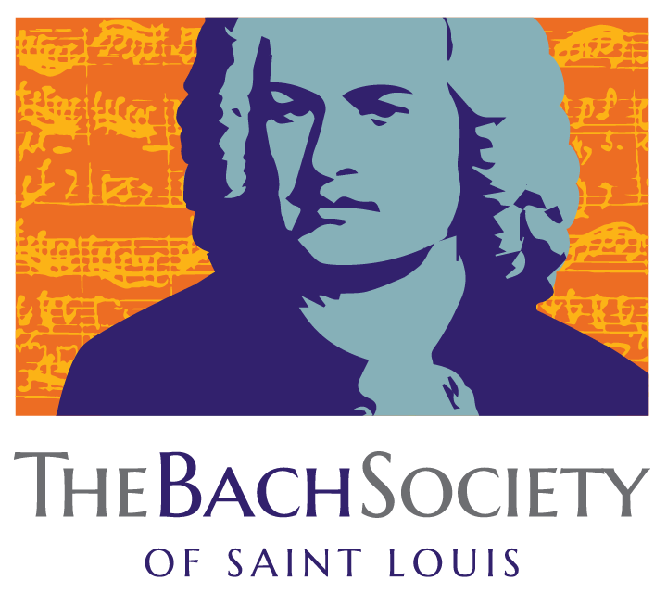
Chorus Rehearsal Protocol
for the 2021-2022 Concert Season
Adopted July 12, 2021; subject to change

COVID Vaccination: Members of the Bach Society Chorus are now required to be fully vaccinated per the CDC guidelines. Every member must provide proof of vaccination prior to the first rehearsal of the season (August 30, 2021). Details about how to provide proof of vaccination will be shared at a later date.

Pre-Rehearsal Health Self-Check: Every member will be required to perform a health self-check consistent with the CDC health guidelines prior to each rehearsal. Members who have a fever, cough, or any hint of illness are excused from in-person rehearsal and should stay home. A remote attendance option for sick individuals is still under consideration and the attendance policy will be more relaxed than in years past.

Sign-in Sheet: Attendance for in-person rehearsals will be recorded and retained for contact tracing. By signing in, members assert that they are symptom-free prior to the start of each rehearsal.

Liability waiver: Prior to the first rehearsal, each member will sign a form waiving liability against BSSL relating to COVID-19.

Masks will be required for all singers and staff during rehearsals. VocalEase masks will be provided by BSSL and are required for dress rehearsals and performances only.

Social Distancing will be followed with the recommendation of approximately 3 feet between singers.

Initial Rehearsals will be limited to 2 hours with no break, and we ask singers reserve the new rehearsal time of 7:00 p.m. - 9:00 p.m. Please note that this window will likely expand from 7:00-9:30pm after the October concert.

Printed Music: Copies will be handed out at the first rehearsal in the same manner as before.

Additional Visitors: For now, we will prohibit visitors from attending regular rehearsals.

Audience and Concert Safety Protocol: A detailed protocol will be released prior to the start of ticket sales for each concert, taking each venue into consideration, along with health data and local restrictions. The COVID Response Committee will reevaluate safety considerations for each event of the season.

COVID-19 Exposure: Members who have been exposed or tested positive for COVID should notify BSSL immediately. We will comply with public health recommendations and will notify anyone who attended a rehearsal and was at risk of exposure. If a singer receives a positive test, we ask that they refrain from attending rehearsals for the duration recommended by the CDC at that time.

